Verification Web Instructions
Clicking on Verification will give you access to the area where you will determine the correct number of households to verify.
Verification Selection Process – Follow the steps below to determine the SFAs non-response rate for last year and the number of households the SFA will need to verify.
Step 1 is used to determine the SFA’s Non-response Rate from the previous school year. Using information from the previous year’s Verification Collection Report, Section 5-8 report the number of applications in each box. Below is a picture of the chart on 5-8 with the locations identified.
Verification Collection Report – Section 5-8
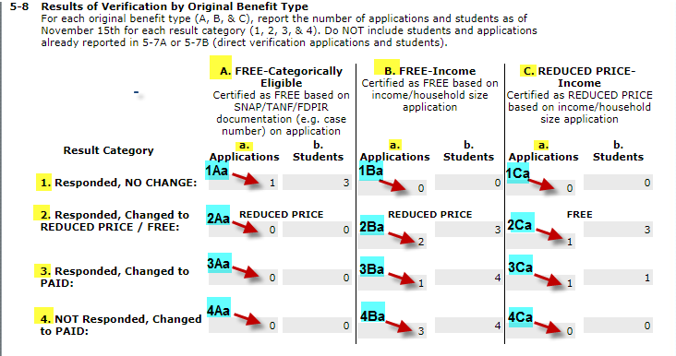

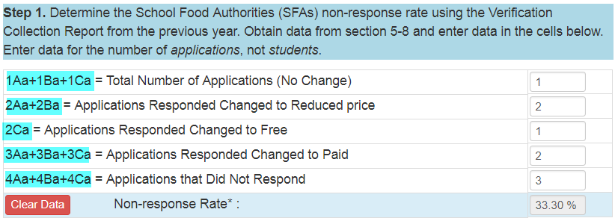

Non-response Rate
SFAs with a non-response rate less than 20% may use any of the 3 sample size processes. SFAs with a non-response rate 20% or greater must use the Standard Sample Size process.
Once you have determined your non-response rate, proceed to Step 2.
Step 2 is where you will enter the number of applications on file as of October 1st. The information is automatically saved. Go to Step 3.
Step 3 is used to calculate the number of applications to verify. You will click on the verification sample size process button you are using (Standard, Alternate One, or Alternate Two). This will then give you the number of applications to verify. Do the exact number, no more or no less.
If the Non-response rate from Step 1 is 20% or greater only the Standard button will display.
Below are descriptions of the 3 sample size processes.
There are three sample size processes established for verification activities as described below. The Standard Sample Size must be used by School Food Authorities (SFAs) unless the SFA qualifies to use Alternate One Sample Size or Alternate Two Sample Size.
Standard Sample Size
The Standard Sample Size and process MAY be used by any SFA. It MUST be used by SFAs that had a 20% or higher non-response rate last year.
The SFA must verify 3% of all applications or 3000 applications, whichever is less, BUT NO MORE. The SFA must choose the sample selection first from applications that are considered error prone. Error prone applications are those with income within $100 monthly or $1200 annually of the upper limits of the income eligibility guidelines. If there are not enough error prone applications to complete the sample, the remainder of applications to be verified are selected randomly from all applications subject to verification.
Alternate One Sample Size
The Alternate One sample size and process MAY be used by an SFA that had a non-response rate of less than 20% last year.
The SFA must verify 3% of all applications or 3000 applications, whichever is less, BUT NO MORE. The SFA must choose the sample selection randomly from all applications subject to verification.
Alternate Two Sample Size
The Alternate Two sample size and process MAY be used by an SFA that had a non-response rate of less than 20% last year.
The SFA must verify 1% of all applications or 1000 applications, whichever is less, PLUS 0.5% or 500 of all applications approved on the basis or Food Assistance (FA) or the Family Investment Program (FIP). The SFA must verify this number, BUT NO MORE. The SFA must choose the 1% sample selection from error prone applications. If there are not enough error prone applications to complete the sample, the remainder of applications to be verified are selected randomly from all applications subject to verification.

